DETECTION OF OCULAR DISEASES:

DIABETIC RETINOPATHY:

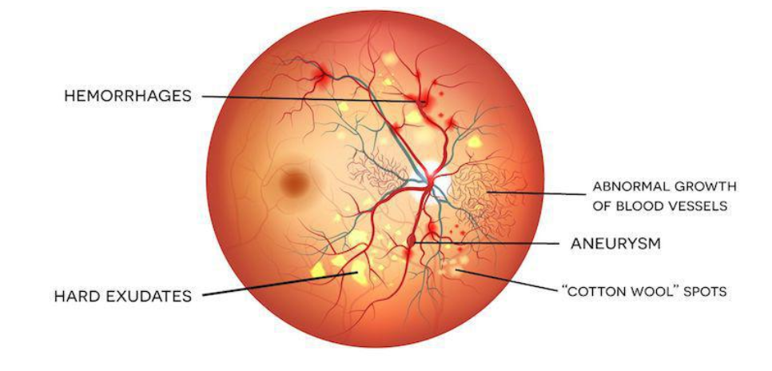

RELATIVE AFFERENT PUPILLARY DEFECT:

